2020-2021

Catalog

**Mentoring Students to become Christ-Centered Leaders**

**Contents**

#### Page

**2** Faculty

**3** From the President

**4** Mission and Doctrinal Statement

**5** Student Spiritual Life at MAS

**7** Academic Programs

Bachelor of Theology

Master of Divinity

Certificate in Biblical Studies

Diploma in Biblical Counseling

Doctor of Ministry

**8** Accreditation

**9** MAS’ 3-Fold Curriculum

The Student learning in the classroom

The Student learning in the church and the world

The Student learning from a mentor

**11** For those not having a Bachelor’s degree

**15** Policies

Registration

Tuition and Fees

Scholarships

Transfer Credits

**19** Course Descriptions

**22** Textbooks

**

**Metro Atlanta Seminary**

5794 Park Central Ave

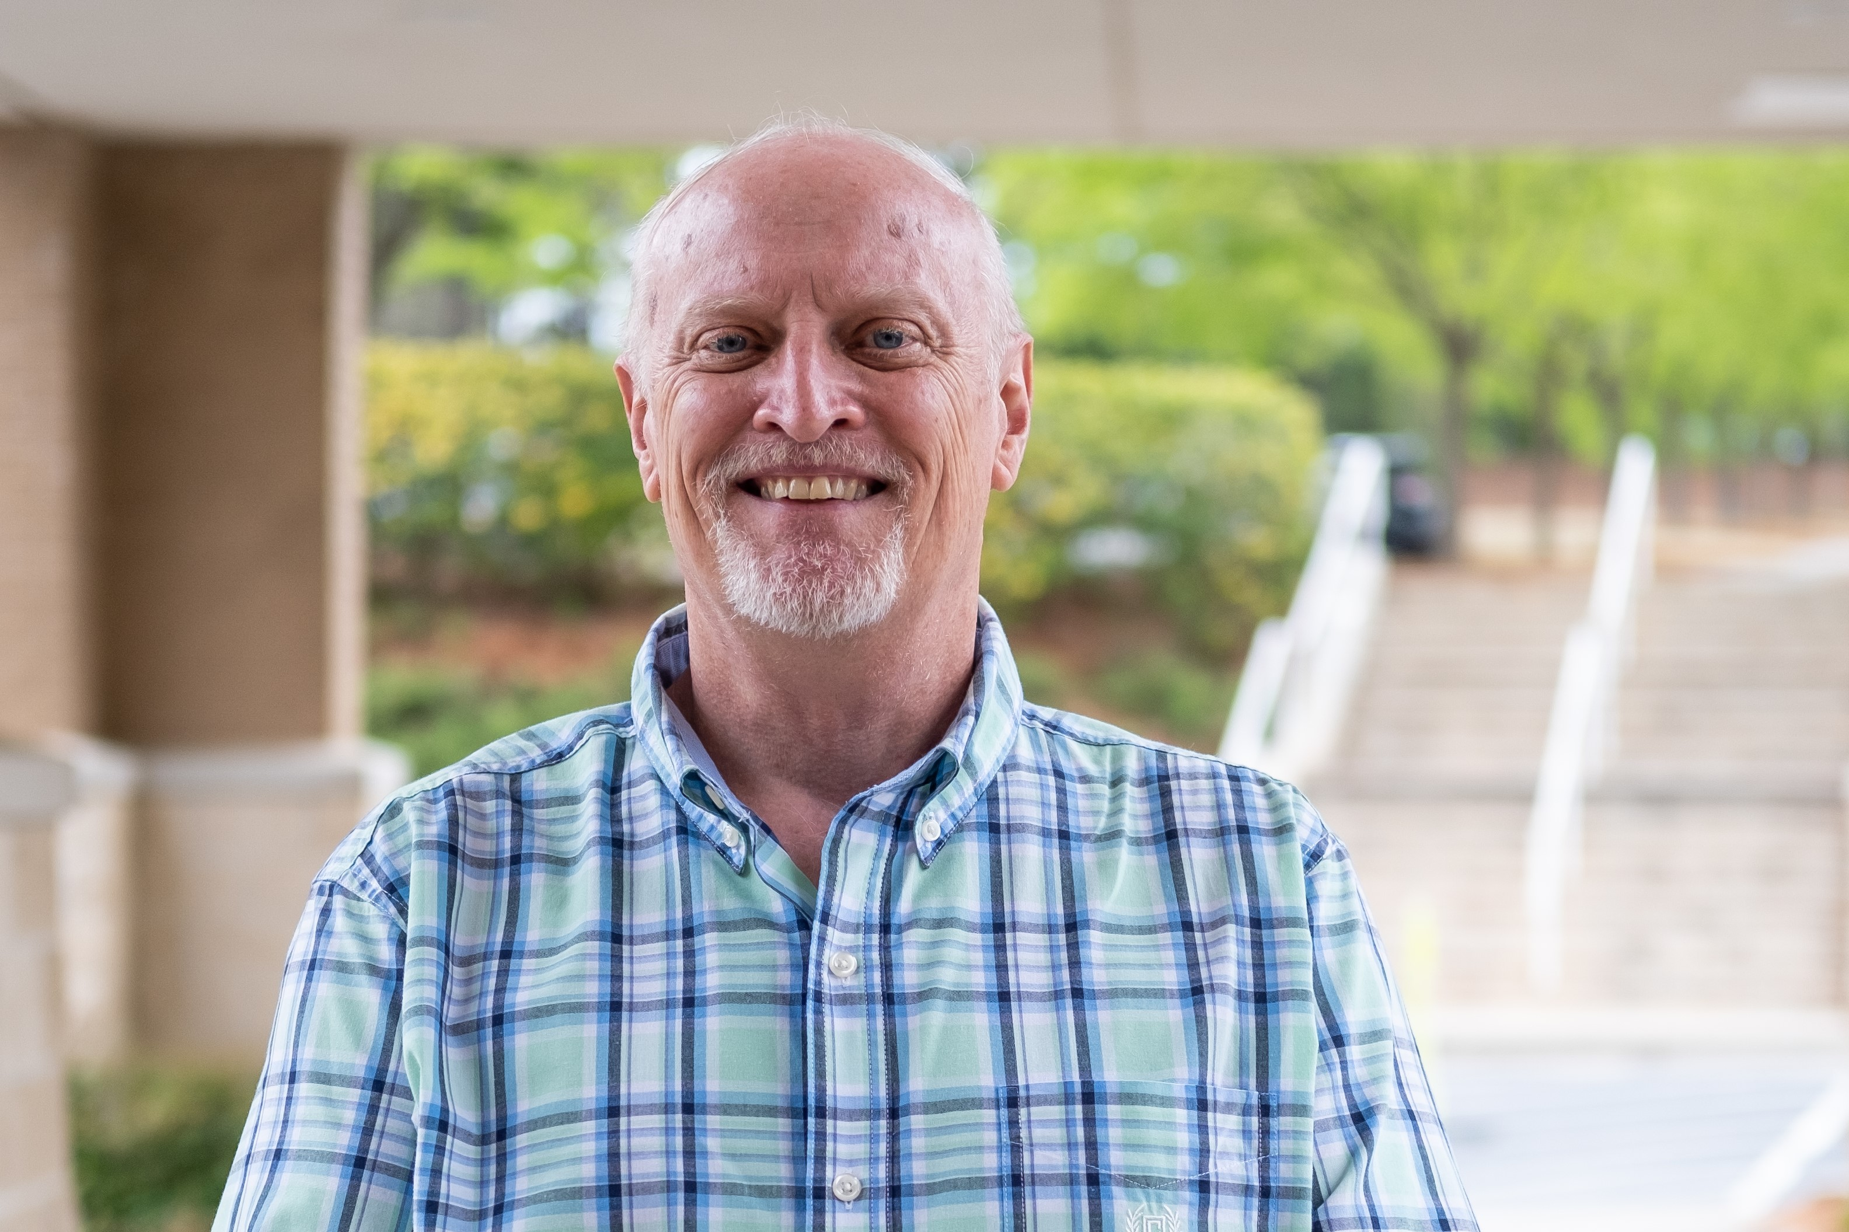Peachtree Corners, GA 30092

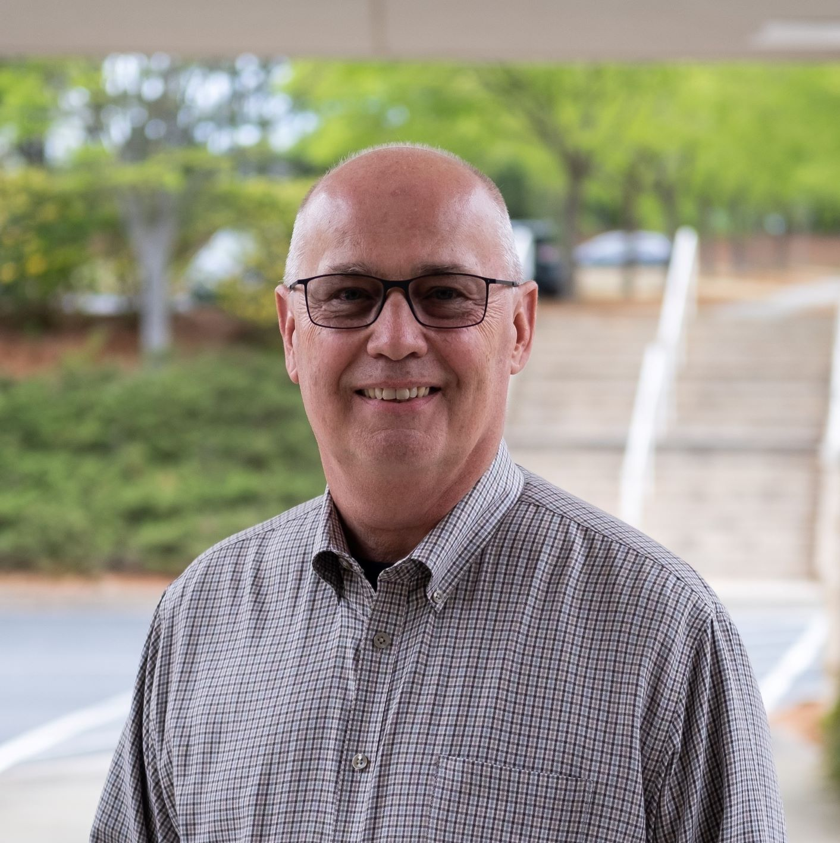

**Contact Details**

Telephone: 678-296-1532

E-Mail: [admin@metroatlantaseminary.org](mailto:admin@metroatlantaseminary.org)

[www.metroatlantaseminary.org](http://www.metroatlantaseminary.org)

Dennis Bennett

Dean of Academics

Joe White

Executive Director

**ADMINISTRATION**

President - Randall Schlichting

Executive Director - Joe White

Dean of Academics - Dennis Bennett

Dean of Mentoring - Robert Carter

Financial Officer - Denise Host

**FACULTY**

Mr. Nate Benard, MDiv (instructor intern)

Rev. Dr. Dennis G. Bennett, BA. MDiv, DRS

Rev. Robert Carter, M.Ed., DMin (candidate)

Rev. Dr. McKay Caston, BA; MDiv; DMin; PhD

Rev. Dr. Charles H. Dunahoo, BA, MDiv, DMin.

Rev. Neil Gilmour, BA, MDiv, ThM

Rev. Hershell Hatcher MDiv (instructor intern)

Dr. Thomas Lutz, MDiv, DMin

Rev. Matthew Means, BA, MA

Rev. Dr. Michael Rasmussen, MDiv; PhD

Rev. Randy Schlichting, BS, MA, MDiv, DMin (candidate)

Dr. Robbie Sherrill, BS, MA, Doctor of Counseling

Mr. George Vaughan MDiv (instructor intern)

Mr. Joseph White MBA. M.Div. (instructor intern)

Rev. Tolivar Wills, MDiv.

**From the President**

We know there are a lot of seminaries in America and across the world. We support and applaud each of those institutions for the work they are doing. At Metro Atlanta Seminary, we make no claim to be better, but we do believe we are distinctive. The founders of the seminary held to a few simple values even as we do now.

1. We believe seminary education should be **mentor-based.** By that we mean each student should have a mature person in his or her life who meets with him or her regularly, asks the good and probing questions and helps each gain what is needed both to be changed and to bless others. There is no substitute for time spent with a godly mentor. Mentors at MAS are trained, not only to connect with students and coursework, but also to take them to the good news of the Gospel through the heart.
2. We believe seminary should be **academically rigorous and relevant to today’s life and ministry.** At MAS, classes are small, interaction is lively, and shared knowledge is brought to the table. Professors are charged with teaching and helping students learn at a graduate school level. (Adult learners prefer to discover answers for themselves more than be told the answers.) Assignments are thought provoking and relevant to the situations of the day. They ask the deeper and probing questions. What do we believe students need to know? What do we want students to be? What do we want them to be able to do? (To know, to be, and to do.) Those three questions are integral to the process of successful graduate study. They permeate every syllabus and expected outcome.
3. We believe everyone should be able to go to seminary, debt free, if they have a calling to do so. By that we mean our fees are minimal and we offer scholarships when needed. We don’t enable poor scholarship or stewardship but rather we teach the way of working out your theology in a practical life manner.
4. We believe a plumber learns to plumb by unstopping his first toilet. By that we mean MAS students are required to get out into the field and get their hands dirty, learning as they go. Our **practicum** serves students well as a framework for changing their lives and ministries, not just checking a box. For those called to ministry the practicum includes teaching, being with people, connecting with the world, and serving. For those called to business, it includes learning how to minister in the marketplace. It is hands-on discipleship.

Classes meet one night per week for 32 weeks per year. Professors are down-to-earth, and we often share a good laugh. By the grace of God, we are mentoring students to become Christ-centered leaders for the next generation in ministry and the marketplace. Lastly, our team is amazing. Men and women who know they are loved by God and who live out their calling to help others learn about Him.

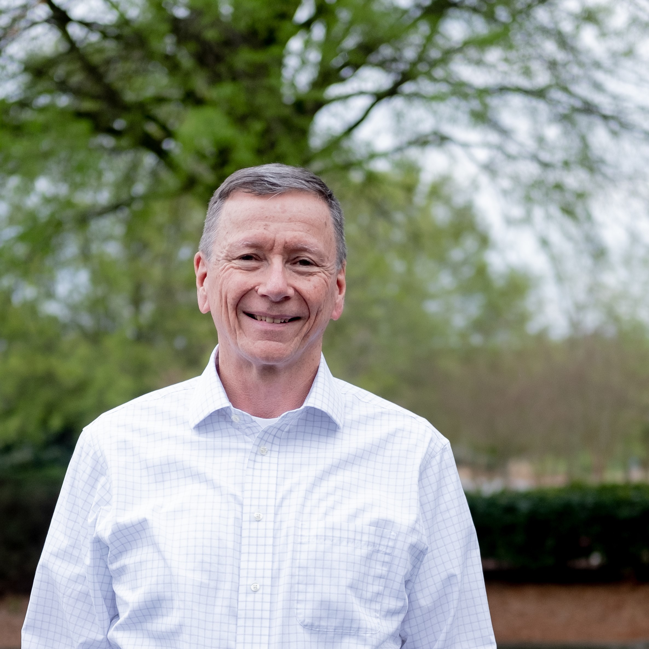

Gratefully,

Randy Schlichting

Randy Schlichting

President

**Mission and Doctrinal Statements**

**“Metro Atlanta Seminary was created to educate and mentor students to become Trinity-centered so they will be leaders in the church, fulfilling the Great Commandment and the Great Commission.”**

Our beliefs lead us to our actions. If we believe God is good, we will act in a way in keeping with that belief: except when we forget, or choose to disbelieve. When we disbelieve, we are called to repent and ask for faith to believe. Throughout church history, leaders have given a snapshot of what we believe and aspire to live out in the Apostle’s Creed, the Nicene Creed, Westminster Confession and Catechisms, and the Heidelberg Catechism. [Remember: our Standard is the Bible, these are subservient to God’s Word.] Those reflect what the church believes in part and they contain key aspects of our doctrinal positions. As you join the MAS faculty we want to ask you this, “What do *you* believe?” Some might say that question should be posed to students, and it is.

1. We believe the Bible is the Word of God and revelation of God. We therefore accept the trustworthiness of its historical records as inerrant in its original writings, the authority of its teachings, and the truth of all Christ's utterances contained in it.
2. We believe in one God, eternally existing in three persons: Father, Son and Holy Spirit.
3. We believe in Jesus Christ the only begotten Son of God, who was conceived by the Holy Spirit, born of the Virgin Mary, and is therefore true God and true man.
4. We believe our Lord Jesus Christ lived a perfect life and died for our sins according to the Scriptures, voluntarily bearing our guilt and suffering as our substitute.
5. We believe all who believe in Him are now justified by His blood, and shall be saved from the wrath of God through Him.
6. We believe in His corporeal resurrection, His ascension into Heaven, and His present life there as our Priest and Advocate.
7. We believe man was created in the image of God, that he sinned and thereby incurred not only physical death, but also spiritual death, which is separation from God. As consequence of the Fall all human beings are born with a sinful nature.
8. We believe in the universality and heinousness of sin, in the necessity of being saved by grace, that sonship with God is attained only by regeneration through the Holy Spirit by faith in Jesus Christ.
9. We believe in the personality and the godhead of the Holy Spirit Who came down upon earth on the day of Pentecost, and we believe in His offices to convict the world in respect of sin and of righteousness and of judgment, and to indwell believers as their Teacher, Sanctifier and Comforter.
10. We believe in the Great Commission which our Lord has given to His Church to disciple the world; this is the great mission of the Church.
11. We believe in the Great Commandment our Lord gave to us to love others even as He has loved us.
12. We believe in that blessed hope, the personal return of our Lord and Savior, Jesus Christ.
13. We believe in the bodily resurrection of the just and the unjust; the judgment of the living and of the dead; the everlasting blessedness of the saved; and the everlasting punishment of the lost.
14. We hold to the system of doctrine as contained in the Westminster Confession of Faith and the Larger and Shorter Catechisms.

**Student Spiritual Life at MAS**

As you consider MAS as a place to learn and grow in your preparation for your Christian service to the Lord, you will discover MAS is a unique place, and a special family. Not only is MAS well-known for its ministry-oriented training of men and women, but also for its emphasis on spiritual growth and nurturing. We want students to become more like Christ as they study at MAS.

The seminary offers a range of programs, taught by a faculty committed to the historic evangelical and Reformed faith, both as creedal affirmation and as living experience. Furthermore, MAS seeks to shape the whole of its corporate life to educate, nurture, and mentor men and women to become mature leaders in their Christian vocations wherever in the world the Lord might lead.

MAS places a very high premium on the development of Christian character, and to that end, close contact between students, mentors, and faculty is promoted. Active participation in your home church in worship, and growth in spiritual disciplines, is considered an essential part of the educational process. Mentoring is a critical factor to growth and success, so much so you cannot graduate without your mentor being in agreement you are ready.

**Walking with Christ While in Seminary**

Sadly, some students who have gone to seminary have come out from the experience calling it ‘cemetery’. They have been left dry and dusty in their faith. We are committed to having students graduate from MAS who say it was a rich time for them spiritually, emotionally, and academically. We ask that students think about the following areas in their lives as they enter into MAS:

**Your relationship with God -** Busyness of life will kill your relationship with Him. You are “adding on” to your life by taking on seminary studies. So the question is, “What will you put aside?” It might be entertainment, social time, or recreational reading, but it cannot be time with the Lord. The Lord desires you trust and love Him with all your heart (Deut. 6:5; Prov. 3:5) and walk humbly before him (Mic. 6:8). In other words, as you run the Christian race, you are to fix your eyes on Jesus and throw off every sin that entangles (Heb. 12:1-2). It is with such an attitude the Spirit is pleased to work in your life and fulfil the Lord's commands. Such spiritual fruit includes love, patience, kindness, and self-control (Gal. 5:22). You are encouraged to read the Scriptures with this in mind, always combining the Word with faith (Heb. 4:2); and continually praying to your Father who loves you and delights in you (Zeph. 3:17; 1 Thess. 5:17). So a daily time with Him is essential and supersedes the reading of any material for class.

**Your relationships with others -** Again, your time at MAS could rob you of relationships with people. We think it is fine for you to see your friends a bit less as you study, but don’t neglect your family! We have seen too many in the ministry who have ignored family as they climb to the top. We rather you not. All God commands is summarized by loving others (Gal. 5:14). In the context of MAS, this has special reference to your relationships with other students. We encourage you to look after the interests of your fellow students and in humility consider them more important than yourself (Phil. 2:3-5). Considering the widely differing church and cultural backgrounds of all who come to MAS, your time here will be one of growing to love, accept, and appreciate others different from you. In fact, this diversity is one of MAS's most desired features. Please pray for and seek to cultivate loving relationships with everyone in the student body, and not only with those with whom you have most in common.

**Promotion of Spiritual Growth** - The Christian needs constant spiritual nourishment, something only possible in the context of prayerful and systematic Bible study and meditation. A spiritual life not renewed on a daily basis soon withers. It is like a stream evaporating in a desert. Attendance in classes on Bible subjects are no substitute for personal devotions!

**Mentoring** – Mentoring at MAS is perhaps our greatest distinctive. Each student has a mentor who meets with him or her regularly for a time of reflection, sharpening, and asking the probing questions. Most classes require you to engage with your mentor for some of the assignments. We want students to rub shoulders with men and women who have hearts and experience in ministry. We want you to open up, reveal weaknesses where appropriate, and gain strength as an older person points you to Christ. Mentoring at MAS is the heart of who we are and we believe it will be one of the things that will cause you to say seminary was a rich time for your spiritual life.

**Student Association/Alumni -** As mentioned, we believe the MAS experience will mark your life in a spiritually rich way. A large part of that will be through your fellow students. As a student you are automatically enrolled as a member of the **MAS Student Body.** It is an association of current and former students who gather together to encourage one another, support the work of the school, and support each other in their vocational call. The Dean of Students can give you more information.

It is the hope and goal of MAS that students will learn what it means to become more Christ-like in all aspects of their lives. To that end, the goals of MAS are deigned to aid each student in using the means of grace to be empowered by the Holy Spirit to walk by the Spirit in a way that reflects the image of Christ to the world by being transformed by the renewing of the mind:

1. By **the basis of faith itself**. In particular, an unequivocal stand on biblical inerrancy, with all that that involves in terms of true Christian assurance. This is seen as a powerful stimulus to spiritual growth.
2. By **the example of Board members and teaching staff**, all of whom are required to be people of spiritual maturity and understanding, subscribing wholeheartedly to the doctrinal statements and their implications. They sign their agreement to these standards every year.
3. By **ascertaining**, as far as is possible through references’ forms, **that every intending student has been born again** into the Kingdom of God and is already demonstrating spiritual growth. Their past ministry in their homes, local churches, and other Christian spheres is assessed.
4. By **the lectures** in which the Bible is clearly portrayed as the Word of God and taught (so far as may be) with a warm and hortatory spirit.
5. By formal or informal **sessions of students** with their mentors. These times of fellowship afford an opportunity for pastoral and vocational counseling.
6. By **attendance at local church services**. MAS students can continue to attend their own home churches. This allows opportunities for service and the ability to be evaluated for suitability for ministry by people who know them best.

**Academic Programs**

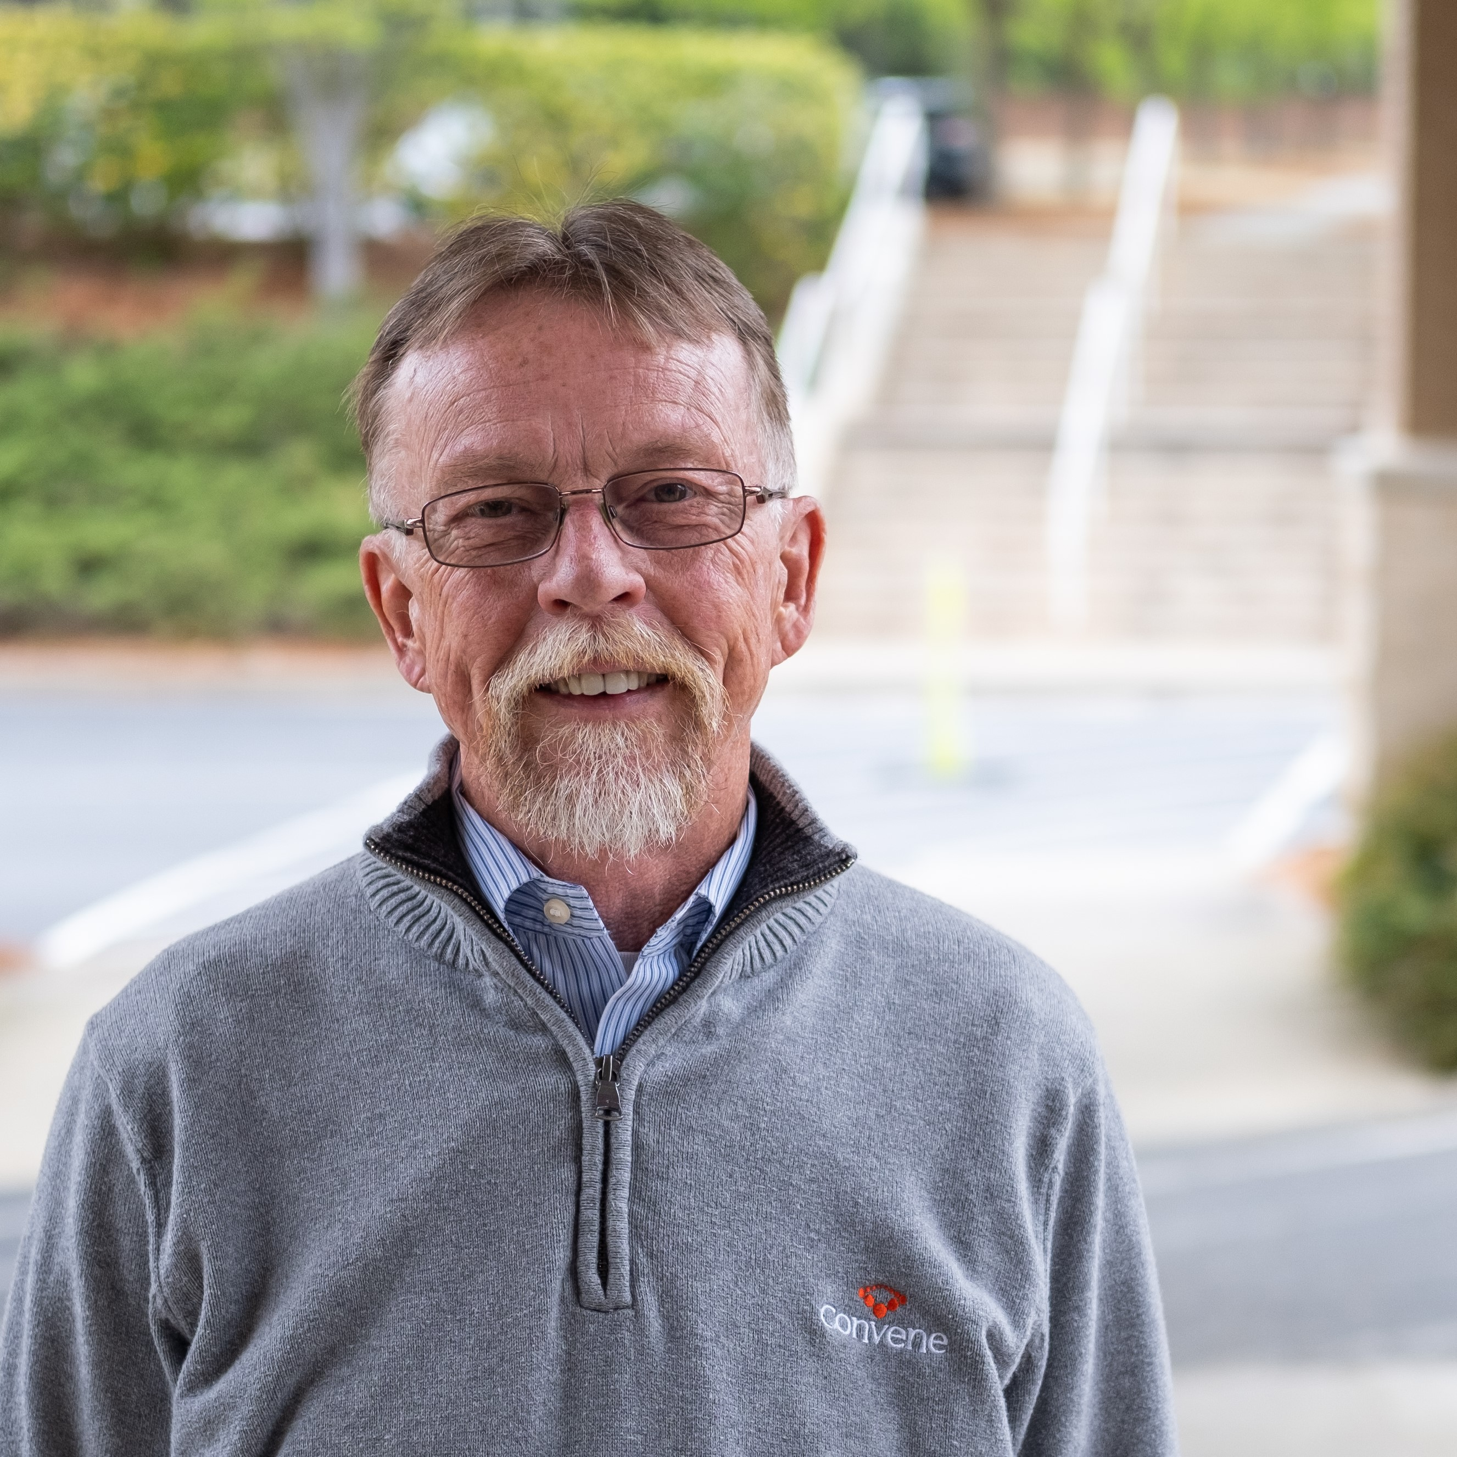**CERTIFICATE IN CHRISTIAN STUDIES (C.C.S)**

The **CCS** is designed for those who are drawn to know more about God, faith, and the church in a seminary setting of academics and mentoring. The **CCS** can be completed in one year on a full-time basis or two years taking **only** one course per week. The **CCS** mirrors the curriculum for the first-year students in the MDiv program, consisting of 12 credit hours of academic study covering Church History, the Old and New Testament (survey courses), theology, and your choice of Sermon Prep or the Teaching and Learning course. Students also meet with a mentor for three terms. There are no Practicum requirements.

Tom Lutz

**Entrance requirement:** High School Diploma

**BACHELOR OF THEOLOGY (B.Th.)**

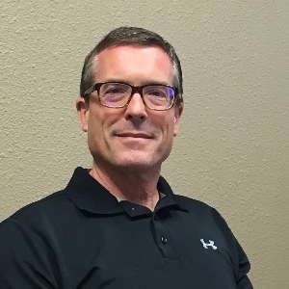

The ***Bachelor of Theology*** (B.Th.) is a three‑year course of study intended to prepare graduates for the Christian ministry. Along with studies in Old and New Testament, Theology, Church History, and Biblical Languages, each student is required to be heavily involved with a local church working with a mentor in order to complete the rest of the program known as the “Laboratory/Internship Curriculum.” (See the *Curriculum* section for details.)

The B.Th. curriculum is identical to the M.Div., but offered to those without a bachelor degree. [See bottom of page 12.]

Michael Rasmussen

**Entrance requirement**: High School diploma or equivalent.

**MASTER OF DIVINITY (M.Div.)**

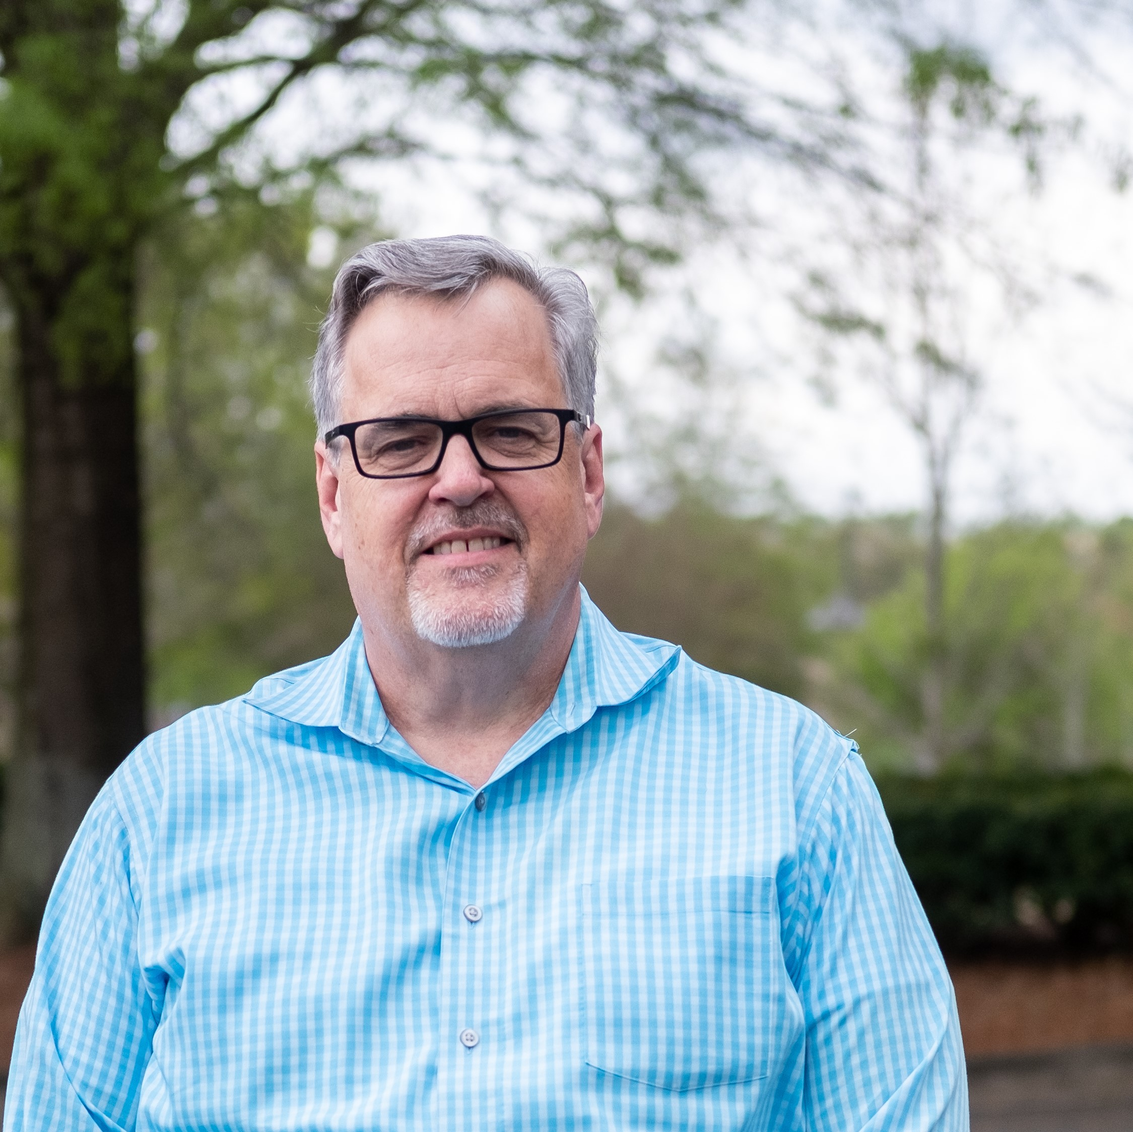

The ***Master of Divinity*** (M.Div.) is a three‑year course of study intended to prepare graduates for the Christian ministry. Along with studies in Old and New Testament, Theology, Church History, and Biblical Languages, each student is required to be heavily involved with a local church working with a mentor in order to complete the rest of the program known as the “Laboratory/Internship Curriculum.” (See the *Curriculum* section for details.)

**Entrance requirements**: A bachelor degree from an accredited institution.

Bob Carter

Dean of Mentoring

**DIPLOMA IN BIBLICAL COUNSELING (DBC)**

How do we define “Biblical Counseling”? Biblical counseling seeks to bring focus and clarity in addressing human problems from the unique perspective, training, and judgment of a biblical counselor who has theological training. The biblical counselor is aware of the value of other helping disciplines such as psychology, sociology, social work, and secular counseling. However, the biblical counselor holds as the highest value the ministry of the Holy Spirit, working in the individual as the counselor walks 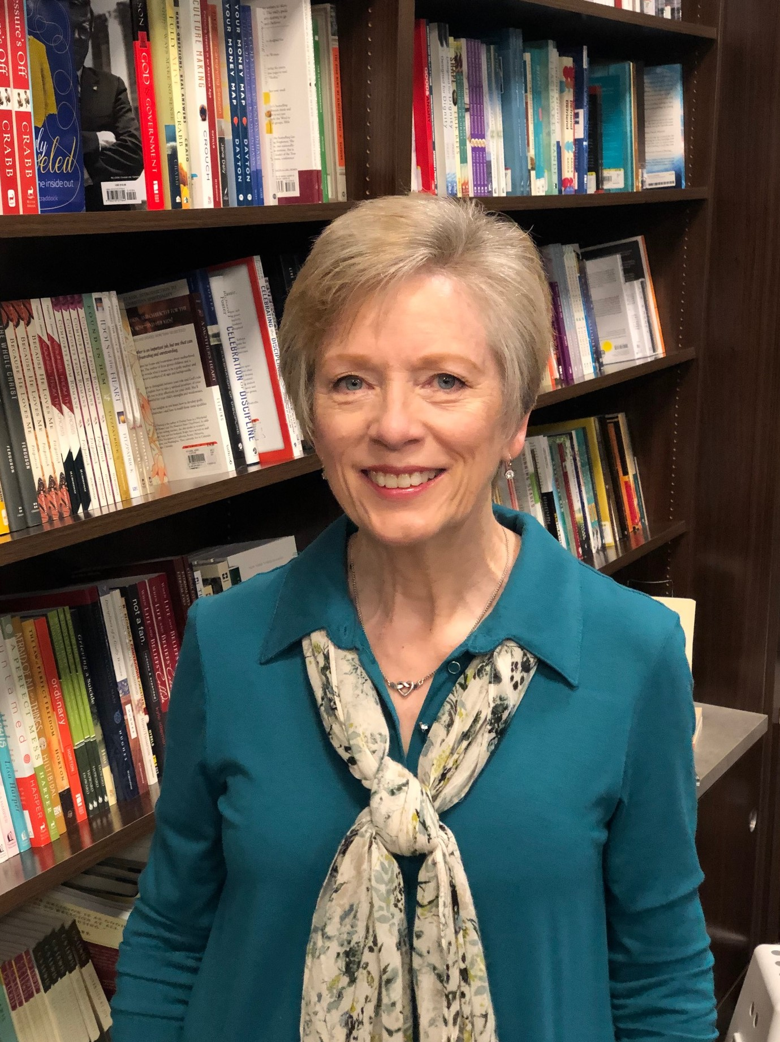alongside those in need, prescribing healthy steps toward growth and change. This work is theological in nature, pastoral in focus, and life-changing in intention. This two-year program does not lead to a state license in counseling, rather, it is to equip men and women in the congregation to serve other members in need.

Along with the Biblical Counseling courses the student will also receive biblical and theological training from MAS’ core curriculum (which are transferrable to other MAS programs). If a student has already taken MAS’ core courses, they need not be repeated.

**Entrance requirement:** High School Diploma

Robbie Sherrill

Director of DBC

**DOCTOR OF MINISTRY IN GOSPEL RENEWAL AND PASTORAL LEADERSHIP (D.Min.)**

In August of 2020, MAS will launch a three-year program leading to a Doctor of Ministry in Gospel Renewal and Pastoral Leadership. The MAS DMin is primarily designed for people who have been in ministry at least five years. Its focus is church renewal, leadership, and revitalization. Under the direction of faculty advisors, candidates will come together quarterly for a full day in a flipped classroom format to gain essential learnings from seasoned professionals in personal renewal, organizational leadership, congregational renewal, managerial leadership, community renewal, and community leadership. Additionally, they will meet with a mentor on a monthly basis as well as monthly coaching cohorts. The program requires extensive reading and writing. It also includes a **Cornerstone Summary Research Paper** as well as an intensive week of learning.

**Entrance requirement:** Appropriate Graduate Degree and five years experience

**ACCREDITATION**

MAS is accredited by the *Association of Reformed Theological Schools* (ARTS). ARTS is an accrediting agency which in 2020 is applying for status under the *Council for Higher Education Accreditation* (CHEA).

The State of Georgia considers MAS a religiously exempt institution.

“This institution is exempt from authorization under O.C.G.A. § 20-3-250.3(a)(6) Nonpublic, nonprofit, postsecondary educational institutions which demonstrate annually to the satisfaction of the commission that their purposes are solely to provide programs of study in theology, divinity, religious education, and ministerial training, and they do not grant postsecondary degrees of a nonreligious nature and that such institutions: (A) Accept no federal or state funds; and (B) Accept no student who has a federal or state education loan to attend such institutions.”

**Curriculum Portfolio Part I – The In-Class Program**

CERTIFICATE[1], BACHELOR’S, and MASTER’S CURRICULUM

**Each quarter is equal to 8 weeks. Each credit equals one 70 minute class hour per week for 8 weeks.**

|  |  |  |  |  |  |  |  |  |  |  |  |  |  |  |  |
| --- | --- | --- | --- | --- | --- | --- | --- | --- | --- | --- | --- | --- | --- | --- | --- |
|  | 1st YEAR **2019-2020** | **1** | **2** | **3** | **4** | **2nd YEAR\***  **2020-2021** | **1** | **2** | **3** | **4** | **3rd YEAR\***  **2021-2022** | **1** | **2** | **3** | **4** |
| **BIBLE** | Old Testament Survey  New Testament Survey | 2 | 2 |  |  | Greek for Bible Study  NT Book Exegesis | 2 | 2 |  | 2 | Hebrew for Bible Study  OT Book Exegesis | 2 | 2 |  | 2 |
| **SYSTEMATIC AND HISTORICAL THEOLOGY** | Doctrine of Scripture  Hermeneutics  God, Man, Sin  Survey of Church History | 1 | 1 | 2  1 | 2 | Person of Christ  Work of Christ  Doctrine of Church & Worship | 1 | 1 | 2 |  | Denominational History  Holy Spirit and Salvation  Ethics and Leadership | 1 |  | 2 | 1 |
| **MENTORING**  **PRACTICUM[2]** |  | [1]  [3] | [1]  [3] | [1]  [3] | [1]  [3] |  | [1]  [3] | [1]  [3] | [1]  [3] | [1]  [3] |  | [1]  [3] | [1]  [3] | [1]  [3] | [1]  [3] |
| **THEOLOGY IN**  **PRACTICE** | Sermon Construction |  |  |  | 1 | KP Workshop  Evangelism/Apologetics |  |  | 1 | 1 | Teaching and Learning  Making & Equipping Disciples |  |  | 1 | 1 |
|  | Yearly total hours = 12/[28] | **3** | **3** | **3** | **3** | Yearly total hours = 12/[28] | **3** | **3** | **3** | **3** | Yearly total hours = 12/[28] | **3** | **3** | **3** | **3** |

REV. 7/5/2020

*NOTE: Each year, Second and Third year classes are combined and repeated only every other year.

The criteria for evaluating classroom work:

**A** (90-100) = work done by the student *exceeds* what was required in the syllabus

**B** (80-89) = the student has completed every requirement in the syllabus

**C** (70-79) = all work was completed, but could have been better

**I** = the student has not *yet* completed all required work and has been granted extra time to finish

**F** = the student has failed to complete *all* the required work in the time permitted

B.Th. and M.Div. PATHWAY

**Curriculum Portfolio Part II –**

**The student learning from a mentor (12 credits/120 hours)**

Who can know the heart of a person? The hope of MAS is, while in seminary, each student will grow spiritually. The purpose of a mentor is to come alongside the student, so he/ she gets to know himself/ herself even as he/she gets to know God personally and intimately. Further, a mentor's role is to encourage a student to have a plan for spiritual growth and to work that plan as enabled by the Holy Spirit.

A mentor meets regularly with a student to ask questions, get beneath the surface, and help the student learn what it means to develop a deeper relationship with the Lord and others. During this time the mentor may encourage, give wisdom, coach, or direct as needed. The mentor will meet with the student and family as needed, communicating through email, text, phone, and face-to-face.

One major objective is for the mentor to help the student develop a written life plan that will become a living, breathing document, to be updated each year with the student’s vision for what he or she is to become in Christ. Most importantly, the mentor is the one who checks the heart, by the power and wisdom of the Holy Spirit, praying the student is changing and becoming more like Him. The total amount of time spent with the mentor amounts to ten hours per term.

Measuring a person’s readiness for ministry is always difficult as it is a subjective judgment. However, after the student and his or her mentor spend 120 hours together, the mentor will have a good idea if the student is prepared.

Because Part II of the MAS Curriculum Portfolio is so mentor based, evaluation is subjective. Grading is by the completion and evaluation of each task required to fulfil the expected track of the student, and is graded as follows:

**A** (90-100) = work done by the student *exceeds* what was required by the mentor

**B** (80-89) = the student has completed every requirement of the mentor

**C** (70-79) = all work was completed, but could have been better

**I** = the student has not *yet* completed all required work and has been granted extra time to finish

**F** = the student has failed to complete *all* the required work in the time permitted

B.Th. and M.Div. PATHWAY

**Part III – The student learning in the church and the world (practicum = 36 credits)**

Real things happen in the world and not in a classroom. Students must have an opportunity to practice their skills and test their abilities so when the real challenges come, they will be ready. The practicum is not a simulation or experiment on a bench. It is more the idea of a plumber taking an apprentice along to learn how to unstop a toilet. Hands get dirty. Watching a master, and then trying to do what he or she does, can enable the student to learn to become the master.

Each student will work with his or her mentor to determine the exact details of these requirements so they best match with the type of ministry the student plans to enter.

**Pastoral Track**

75 hours – Preach/teach/Lead Worship

60 hours – Spend time with church members

5 hours – Assist in funeral and wedding

50 hours – Spend time with the un-churched

4 hours – Attend X-Press your faith seminary (or other evangelism training)

4 hours – Attend a presbytery meeting & a committee meeting

6 hours – Interview lead pastors

10 hours – Visit the sick

8 hours – Develop a working life plan and budget

40 hours – Engage in missions, local or global

72 hours – Lead a disciplehip group

20 hours – Engage in service to the less fortunate

4 hours – Attend new member classes & interview new members

2 hours – Attend a congregational meeting & an elder’s meeting

360 hours = 36 credits

[Hours listed are minimums.]

**Workplace Track**

72 hours - Teach on a business mission trip; local or global

60 hours - Interview businessmen who are Christians

20 hours - Lead Discipleship group with businessmen

4 hours - Develop of a 5-year vision letter/Kingdom Purpose statement

16 hours - Develop a Life Plan and Budget

6 hours - Develop Keys to Significant Success

10 hours - Development of a personal/departmental dashboard

8 hours – Develop a Ministry Action plan for work including service project

20 hours - Attend an Effective Confrontation Workshop

60 hours - Participation in church ministry

20 hours - Participation in one community service group

20 hours - Develop & Implement workplace outreach program

20 hours - Develop/implement/teach a workplace Bible study/prayer meeting

20 hours - Develop/Implement a development plan for direct reports

4 hours - Attend X-press your faith seminar

360 hours = 36 credit

Ministry Track (Non-Pastoral)

72 hours – Teaching – Examples include developing and teaching bible studies

60 hours – Lead/co-lead a discipleship group

96 hours – Ministry Outside the Church – Examples include service to the less fortunate, interviewing directors of various nonprofits serving outside the church.

4 hours – Attend X-Press your faith seminar, or other approved program on evangelism.

40 hours – Engage in missions local or global

84 hours – Ministry within the Church – Examples include interviewing directors of community outreach and Global Outreach or equivalent at a local church. Visit with your mentor or pastor, homebound, or sick members of the church.

4 hours – Develop a working life plan.

360 hours = 36 credits

The criteria for evaluating **Part III of the MAS Curriculum Portfolio** (the practicum) is completed on a term basis with the final grade reflective of average:

**A** (90-100) = hours completed during the term exceeded 25 hours and the student provided all the appropriate documentation on the Practicum Activity Sheets.

**B** (80-89) = the student has demonstrated they did complete practicum hours during the term and provided the appropriate documentation on the Practicum Activity Sheets, however, total hours were less than 25 for the term.

**C** (70-79) = MAS recognizes that there are periods where the student is unable to participate in working on practicum hours. A student will receive a C provided that reviewed their worksheet for that term as evidenced by uploading it to ThinkWave.

The student must complete the 360 hours practicum work in order to graduate.

To Interested Students Who do not have a Bachelor Degree

Students who do not have an undergraduate degree from a college or university are able to enroll in MAS, follow the Master’s in Divinity pathway, and receive a Bachelor’s in Theology degree.

MAS’ B.Th. degree is based on the British system. There a student enters right into the student’s major without having to take the “core” courses required in the American system. It is presumed courses, such as English Composition and basic math have been completed and learned in high school. This may make work on this level more challenging at MAS. However, since most of our students are older as they come into the program, many of these deficits should have been resolved. MAS will do all it can to help each student to be successful in his/her studies.

**Diploma in Biblical Counseling**



**Add the DMin program**

**Policies**

In addition to the academic qualifications for the intended program of study, applicants are assessed before entry to establish they are Christians who are maturing spiritually. They should be in good standing with their local church, and in a reasonable state of health.

REQUIRED DOCUMENTS

* Application – (found on the website) this will determine

1. genuineness of conversion and commitment to the Lord Jesus Christ
2. present involvement in Christian service
3. a sense of vocation in future service for the Lord

* Three References who can verify the potential student’s readiness for study and service. One of these must be from the applicant’s pastor.
* Photograph
* Copy of high school diploma or GED (CCS and B.Th. applicants only)
* Transcripts from any tertiary institutions. (A minimum of a bachelor’s degree is required to pursue the M.Div.) (If you wish to transfer credit into MAS please also send along the website information from that institution. Be sure it includes course descriptions.)
* $100 application fee (must accompany application or paid on the website)

**REQUIREMENTS FOR ENTRY INTO A DEGREE PROGRAM**

1. **Entrance to the Bachelor in Theology** (BTh) requires the following:
2. The Minimun requirement is a high school diploma or equivalent.
3. The Seminary has a mature entry policy, i.e., a student may be granted mature age exemption if the applicant is 25 or older.
4. Acceptance of the student is based upon the information submitted in the application and three references.
5. **Entrance to the Master of Divinity** (MDiv) is as follows:
6. The minimum requirement is a completed bachelor’s degree substantiated by the submission of a transcript.
7. Acceptance of the student is based upon the information submitted in the application and three references.

**Requirements For Entry Into a Certificate Or Diploma Program**

1. **Entrance to the Certificate in Christian Studies** (CCS) is as follows:
2. Minimum requirement is a high school diploma or equivalent.
3. Acceptance of the student is based upon the information submitted in the application and three references.
4. **Entrance to the Diploma in Biblical Counseling** (DBC)
5. Minimun requirement is a high school diploma or equivalent.
6. Acceptance will be based on information submitted in the application and from the three references as well as the following items. The applicant will also provide a reference and recommendation from their pastor. Candidates will also be interviewed prior to being accepted. In their second year of the program, students will provide a background check.
7. **Entrance to the Doctor of Ministry** requires the following:
8. Five years of pastoral experience
9. Appropriate masters degree in an area of biblical studies
10. Acceptance of the student is based upon the information submitted in the application and three references as specified in the application.

**REGISTRATION & ORIENTATION**

Students can register for classes online at [www.metroatlantaseminary.org](http://www.metroatlantaseminary.org) As we anticipate the arrival of all new and returning students, MAS arranges a schedule of orientation activities at the beginning of each academic year. We strive to provide an atmosphere of Christian unity and fellowship as the faculty, staff, and returning students help to familiarize new students with the program, and various ministry opportunities.

**TUITION AND FEES**

Application Fee…………………………………………….$100

Tuition……………………………………………………..$165 pre credit hour

Language Fee (use of LOGOS) ………………………….$55 per term (w/language course)

Late Registration Fee……………………………………….$25

Audit Fee…………………………………………………...$80 per credit hour

Graduation Fee…………………………………………….$200 (payable student’s last term)

Transcript Fee……………………………………………...$15 each after the first two

**DMin fees…………………………………………………See website for details**

**PAYMENT OF FEES**

Students are expected to pay all fees for each term by the first night of class. If a payment schedule is needed, terms can be arranged with MAS’ Exective Director. All fees must be fully paid before a student can start another term or graduate.

**SCHOLARSHIP POLICY**

Due to the generosity of Christians committed to MAS, scholarship funds are available on a limited basis. These are awarded for one year and must be applied for and are considered for renewal each year.

The Scholarship Application and Instructions are available on the website.

TRANSFER OF CREDIT POLICY

MAS will accept transfer of credit from many accredited schools. A maximum of ten credit hours may be transferred into the academic part of the program. Courses and credits must correlate closely with the courses MAS offers including practicum and mentoring.

Credits from MAS have been accepted by several evangelical institutions. A student wishing to transfer credit from MAS to another institution should acquire specific information concerning the policies and procedures of that institution.

**CREDIT FOR PRIOR LEARNING**

When a student can demonstrate prior learning in a particular subject area, he or she may be exempted from that course by the Faculty Academic Committee. In its place will be a course equal to the amount of credit granted by the prior learning as agreed upon by the student and Dean.

**REFUND POLICY**

Refunds of tuition will be given on the following basis:

1. 75% after the first hour of class
2. 50% after the second hour of class
3. 0% after the third hour of class

**NON-DISCRIMINATION POLICY**

Metro Atlanta Seminary does not discriminate on the grounds of race, color, national and ethnic origin, natural born gender, disability, or age.

**PRACTICUM AND MENTORING COMPLETION POLICY**

Each student is required to be involved in a local church or Christian ministry each academic year working with his or her mentor as he or she practices what is being studied. The practicum is given as a minimum guide to help the student engage in the church and the world. Successful completion of the practicum, with approval of mentor, is a prerequisite for graduation.

**CLASS TIME AND ATTENDANCE**

We view class time not merely as a time of academic instruction, but also as a time of fellowship, when faculty and students together explore the Holy Scriptures, learn God's truth, "grow in grace and in the knowledge of our Lord and Savior Jesus Christ," and find ways of practically implementing, as soon as possible, what has been learned. To that end, class time is essential and absences must have providential as well as faculty excuse. Students are encouraged to attend all classes, and to be punctual. We operate on a short 8-week term, and therefore attendance is critical to success in any subject. Therefore, no student may miss more than one class hour of a one-credit course; 2 class hours of a two-credit course; etc. Students who are unable to attend a class, must contact the professor before the class starts to ask for an excused absence. Students must also contact a fellow student to find out what was missed and what needs to be made up.

**CHANGES TO CURRICULUM**

If a student has been away from the seminary for one year, and the curriculum is changed, the student will be subject to the new curriculum.

**OUTSIDE CLASS STUDY EXPECTATION**

As a basic guideline, a student is expected to do at least two hours of private study for every hour of classroom time.

**SPOUSES**

Spouses who would like to attend classes as auditors may do so at no charge. However, please remember, auditors are there to listen only and should respect the right of degree seeking students to speak and ask questions.

**DRESS GUIDELINES**

Students are to dress appropriately, with modesty, with due respect in consideration of others. This simply means we are all to take seriously the vocation of MAS and all who train here, and to have due respect for those of other cultures. (Rom. 14:13ff)

**GRADUATION POLICY**

To graduate, a student must complete and pass all courses, complete the practicum, and be approved by the mentor.

1. All required courses are taken and passed.
2. The student’s mentor has signed off on the readiness of the student to begin his or her ministry.
3. The student’s mentor has signed off on the practicum/internship part of the curriculum, meaning all the required elements on the checklist have been satisfied.
4. No student will be permitted to graduate unless all outstanding fees have been paid, nor will a copy of their transcript be given or sent until all financial deficits are settled.

**INSURANCE POLICY**

1. **General –** Metro Atlanta Seminary does not provide personal insurance. It is the student’s responsibility to make sure he or she is covered in case of sickness or injury.
2. **Indemnity** – Students, by registering, are holding MAS harmless from any liability or any accident.

**LIBRARY**

Access to great books and papers are important to students. MAS has chosen not to own buildings, which enables us to keep tuition low. Having no building means we cannot have a library. But that does not mean the student does not have access to great books, articles, etc. These can be sourced in the following ways:

1. The use of public and private libraries
2. The development of your own libraries, especially within Logos Bible Software
3. Making good use of the internet, being careful to properly use, notate, and discern the material’s accuracy
4. Talking with faculty who are willing to lend their own books to students
5. Checking with your own pastor and see if he has the books you need and if he is willing to lend them
6. You also have access to two massive libraries at the Chandler Library at Emory and Columbia Seminary. MAS also has secured right of access to the library at Reformed Theological Seminary in Atlanta.
7. MAS will, over the next year, investigate the feasibility of becoming part of a library association such as ATLA.

**ORDINATION**

MAS does not ordain anyone to the ministry. MAS believes this is the sole responsibility of the church.

**Course Descriptions – Certificate, BTh, and MDiv**

**Old Testament Survey**

This is a study of the OT dealing with its content, message, form and background. The survey will introduce the student to the biblical-theological approach to Scripture, showing how the books of the OT point us to God’s Covenant of Grace in the Person and Work of Jesus Christ.

**New Testament Survey**

This course is an introduction to the NT writings and their message in the historical, cultural and religious context of the first century. The aim of the course is to give the student an accurate understanding of the primary backgrounds of the NT writings and other related introductory questions that impact on their message. The course comprises lectures, assigned readings, a written assignment and examination.

**Greek For Bible Study**

The purpose of this course is not to make a person a Greek scholar. Rather, the intent is to give just enough basics of the Greek language to enable the student of the Bible to use the many word study tools written by the Greek scholars.

**Hebrew for Bible Study**

The purpose of this course is not to make a person a Hebrew scholar. Rather, the intent is to give just enough basics of the Hebrew language to enable the student of the Bible to use the many word study tools written by the Hebrew scholars.

**Old and New Testament Exegetical Book Studies**

**Prerequisite: Hebrew for Bible Study (for both OT exegesis courses) and Greek for Bible Study (for both NT exegesis courses)**

These will be chosen by agreement between the seminary and the needs of the students. Two courses in OT and two in NT will be required. These will be taught with two objectives in mind. First will be the plan to cover this course in a way that will enable the student to immediately be able to teach the biblical book to others with application. The second objective is to demonstrate to the students how to use the Greek and Hebrew taught in the Greek and Hebrew for Bible Study courses. Students will be taught how to develop sermons and teaching lessons from the text. Systematic Theology/doctrine will also be covered in a way that will help the student to know how doctrine is developed out of the text.

**Doctrine of Scripture**

The Doctrine of Scripture forms the first part of a two-part course on Scripture and Hermeneutics. Major topics to be covered in part one include the inspiration, inerrancy, authority, necessity, clarity, and sufficiency of Scripture, as well as the canonicity, preservation and the historical reliability of the Biblical documents.

**Hermeneutics**

The Hermeneutics course forms the second part of a two-part course on Scripture and Hermeneutics. Major topics to be covered in part two include: (1) a discussion of the major principles and rules of biblical interpretation, (2) how to use tools for effective Bible study, and (3) how to practice the observation, interpretation, and application method of inductive Bible study.

**Survey of Church History 1 & 2**

This course will enable the student to come away with an understanding of the “time line” upon which God used individuals and events to bring about His desired ends from the end of the first century to the beginning of the 21st century. Particular note will be made of the development of doctrine throughout this period.

**Making & Training Disciples**

**It is a command. Our God calls us to make and train disciples but that is much easier to say then to do. This course offers the student an opportunity to explore his or her own issues with the command and to learn from practitioners of making and training disciples. Course work includes actually thinking about who, what, when and where. The instructors deal with myths of evangelism and seek to help the student rest in the decrees of God while laboring in His field.**

**God, Man, and Sin**

This course seeks to explore the nature, character, and tri-unity of the God who has revealed Himself historically in redemption through His inspired Word, and in the enlightening which comes through the Holy Spirit. It comprises the centerpiece of our theological efforts as it has the Triune God Himself, and therefore the impartation of a profound knowledge of Him, as its focus. God as Maker and Upholder is set alongside a study of humanity; our original and fallen nature, dependence, and destiny. As with all doctrinal courses, the topic is explored along biblical, historical and systematic lines.

**Person and Work of Christ**

The topic of the Person of Christ is a careful study of the relevant biblical material found in both Testaments, and a survey of the doctrine throughout church history. The study on the Work of Christ is drawn from both Testaments and reaches its climax in Paul's epistles and Hebrews. The study encompasses a treatment of all the important views of the work of Christ, and will be compared with other differing viewpoints advanced over the last 2000 years.

**Teaching and Learning**

Most courses that are designed to teach teachers to teach usually teach methods of communication (delivery). This is not adequate because the methods used may not reach the learning styles of most of your learners. We will concentrate first on helping you learn how ***you*** learn. Then you will study the characteristics of the other major learning styles. It will be only after this is understood that we can turn to putting together teaching methods that will enable you to reach all the learners you are charged with teaching.

**The Holy Spirit and Salvation**

The Doctrine of the Holy Spirit and Salvation course will establish a biblical foundation for understanding the person and work of the Holy Spirit, various facets of soteriology, the application of redemption, the gifts of the Spirit and the means of grace.

**Ethics and Leadership**

Does it matter if you take a few paper clips home? Or if you don’t tell the person you are selling to all the features or lack thereof for your product. How much do we need to be examples of transparency in the world? This course will explore the reality of the marketplace and the issues surrounding how a Christian can be successful in business.

**Worship Liturgy and the Sacraments**

This course will examine the subject of corporate worship in the context of the local church. Although the subject of individual worship is certainly of crucial importance, this will only be dealt with as it relates to our corporate worship. What is corporate worship? Do we have to pray? Preach? Sing? What about confession? And how and why are the Lord’s Supper and Baptism tied into the whole thing?

**Denominational History and Polity**

This course will cover the history of Protestant denominations from the Reformation to the present, with special emphasis being given to the rise of the Presbyterian Church in America.

NOTE: Anyone taking this course who is from another denomination may write a study of their own denomination’s history, doctrinal distinctive, and major contributions to the cause of Christ.

**Sermon Construction - Preaching**

This course will be hands on interactive learning time as students understand the principles, but more importantly the heart of preaching

**Kingdom Purpose Workshop**

This course will help students discover, define and place into their life grid their Kingdom Purpose.

**Apologetics/Evangelism**

Every Christian needs to be ready at all times to give a defense for the hope that is in us. This course is meant to help every student to be equipped and trained to witness to anyone without reservation.

**Mentoring**

The design of this program is to enable the candidate to work directly under a seasoned pastor/mentor. During this time it is expected that the protégé shadow the mentor in all that he does. This will also involve the learning of ministry ingredients not covered in the formal teaching part of this program, such as homiletics, ethics, and counseling.

**Practicum (Internship)**

MAS offers three practicums and each is designed to provide the student opportunities to engage in ministry and learn more about their specific calling. Based on the practicum chosen (Pastoral, Ministry, and Marketplace) every effort is made to assign the student a mentor who will also be able to provide guidance and input in that field of ministry.

**Course Descriptions – Diploma in Biblical Counseling**

**Year One Courses**

**DBC 110: Introduction to Biblical Counseling/Human Development**

This course examines the basis for biblical Counseling along with the caregivers call and unique gifting to help others. The students will be introduced to foundational theological concepts integrated with psychology, that relate to care within the church, the community, and in culturally diverse settings. The core counseling skills that characterize a healthy caring relationship will be covered along with caregiving related legal, ethical, and moral issues,

In the second half of the term, which covers human growth and development, the students will learn about the growth patterns of individuals in varying ages and stages of development. Additionally, they will examine developmental psychology, focusing on major theories, concepts, and issues within each developmental stage of the human lifespan.

**DBC 120: Personal Conflict: Identity Issues/Family Dynamics I**

This course is designed to provide students with an overview of an individual’s personal mental image and how that perceived image permeates their self-esteem, character traits, strengths, weaknesses, abilities, physical features, and emotional outcomes during times of significant challenge. They will also study the dynamics of social interactions, singleness, and choosing a marital partner. Both personal image and self-esteem will be examined in relationship to a Biblical view of one’s worth, approval, competence and significance.

The second half of the term will introduce the student to part one of a study in Family Dynamics, which will include a broad understanding of pre-marital, marriage, and family systems. Parenting styles and skills, utilized with infants through young adults, will be presented and examined. The students will participate in role-playing to better conceptualize the issues and corresponding therapeutic techniques that are utilized in Biblical family counseling.

**DBC 130: Family Dynamics II/Prominent Life Issues I**

This course begins with a continuation of Family Dynamics, which will include the topics of pregnancy-infertility, divorce, re-marriage, blended families, and parenting adult children. Once again, the students will participate in role-playing and case study work, giving them opportunities to confront a myriad of challenging family issues while utilizing core Biblical counseling skills.

In the second portion of the term the students will begin to study prominent presenting counselee issues. This course includes the most commonly experienced symptoms of varying types of depression and anxiety. Additionally, the students will become familiar with the etiology, terminology, taxonomy, and treatment approaches utilized in Biblical counseling.

**DBC 140: Prominent Life Issues II**

This course will provide a continuing study on prominent presenting counselee issues. The students will examine real-life challenges, including anger, grief, loneliness, various sexual behaviors, lying, inferiority/shame, guilt and forgiveness. Each issue will be explored through the attitude of contemporary norms compared to the grounding of immutable Biblical truth. The students will become familiar with the etiology, terminology, taxonomy, and treatment approaches utilized in Biblical counseling, applicable to the different presenting issues.

|  |  |
| --- | --- |
| SAMPLE OF REQUIRED TEXTBOOKS | |
| COURSES | TEXTBOOKS |
| For **all** courses | Logos Bible Software – Academic Level (minimum) |
| **All** Doctrine courses | Frame, John, *Systematic Theology*, 2013 |
| Old Testament Survey  New Testament Survey | Hendriksen. *William, Survey of the Bible*, Eerdmans |
| Greek & Hebrew | *Learning to Use Greek and Hebrew*. Logos Bible Software  Black, David, *Learn to Read New Testament Greek*. Broadman, 2009  Van Pelt*,* M., *Biblical Hebrew: A Compact Guide*. Zondervan, 2012 |
| Hebrew Exegesis | Hill & Walton, 3rd Edition. *Survey of OT*, Zondervan, 2000 |
| Exegesis of NT Postcards | Gundry, Stan, *Survey of the NT*. 5th ed., Zondervan, 2012 |
| Exegesis of Titus | Gundry, Stan, *Survey of the NT*. 5th ed., Zondervan, 2012  Mounce, Wm., *Complete Expository Dict.* Zondervan, 2006  Bennett & Poole, *Titus:* *Passing on the Truth*. CDM, 2014 |
| Doctrine of Scripture | McDowell, Josh, *The New Evidence that Demands a Verdict*  Packer, J.I., *Fundamentalism and the Word of God*  Stott, John, *Understanding the Bible* |
| Hermeneutics | Doriani, Daniel M., *Getting the Message*. Phillipsburg, NJ: P & R Pub., 1996  Sproul, R. C., *Knowing Scripture*. Downers Grove: IVP Books, 2016 |
| Holy Spirit and Salvation | Murray, John, *Redemption Accomplished and Applied*. Eerdmans  Caston, McKay, *The Grade Exchange*  Caston, McKay, *Seven Strands of Grace* |
| God, Man, and Sin | Jim van Zyl, *God, Man, and Sin*. Bible Institute of SA, 2019  Frame, John, *Systematic Theology*, 2013 |
| History of Christianity | Shelley, Bruce L., Early, Joseph Jr., *Church History in Plain Language,* Thomas Nelson. 2008. 4th Edition  Holcomb, Justin S., *Know the Councils,* Zondervan Academic, 2014  Holcomb, Justin S., *Know the Heretics*, Zondervan Academic, 2014 |
| Evangelism/Apologetics | MaGrath, Alistair, *Intellectuals Don’t Need God*, Zondervan, 1993  *Optional:* Schaeffer, Francis, *The God Who is There*, IVP, 1998 |
| Making and Training Disciples | Chester, Tim, *A Meal with Jesus*, 2011  Pope, Randy, *The Answer*  Schlichting, Randy, *Minority Rules* |
| Teaching & Learning | LeFever, M., *Learning Styles.* DC Cook, 1995 |
| Ethics & Leadership | The Heidelberg Catechism (pdf supplied by the professor) Questions 92-115  The Westminster Confession and Catechisms (pdf supplied by the professor) Chapters 16, 19, 22 and 24.  Larger Catechism Questions 91-151  A Simple Way to Pray – Martin Luther (pdf supplied by the professor)  God’s Purpose in Creation: A study in Genesis 1 (available at [https://store.tifwe.org/collections/books?page=2](https://nam12.safelinks.protection.outlook.com/?url=https%3A%2F%2Fstore.tifwe.org%2Fcollections%2Fbooks%3Fpage%3D2&data=02%7C01%7Cdbennett%40pcanet.org%7Caf100361e80e40b54acf08d7e6cd5f64%7C0f18fcd7edb64993b4d03112a12a45f4%7C0%7C0%7C637231642058027424&sdata=qwKjsvTStBfEQUueaWRdEhBiihMuqg%2FbLRXcBjRX0ew%3D&reserved=0)) |
| Mentoring Curriculum  and  Practicum Curriculum | All required reading will be found in the *MAS 3-Fold Curriculum Guide* |
|  |  |
|  |  |
| **DIPLOMA COURSES** |  |
| DBC 110: Introduction to Biblical Counseling/Human Development | Collins, Gary, *Christian Counseling, A Comprehensive Guide, third edition*  Stanford, Matthew S., *Grace for the Afflicted.* IVP, 2017  Frame, John M., *Systematic Theology.* P & R, 2013  Sbanotto, Gingrich, *Skills for Effective Counseling.* IVP, 2016  Townsend, *Boundaries with Teens.* Zondervan, 2006 |
| DBC 120: Personal Conflict: Identity Issues/Family Dynamics I | Collins, Gary, *Christian Counseling, A Comprehensive Guide, third edition*  McGee, Robert, *The Search for Significance.* Thomas Nelson, 2003  Crabb, Larry, *The Marriage Builder.* Zondervan, 2013  Backus, Chapian, *Telling Yourself the Truth.* Bethany House, 2014  Smalley, Gary, *The DNA of Relationships.* Tyndale, 2007  Chapman, Gary, *Things I Wish I’d Known Before I Got Married.* Northfield, 2010  Cloud, Townsend, *Boundaries in Marriage.* Zondervan, 2002 |
| DBC 130: Family Dynamics II/Prominent Life Issues I | Collins, Gary, *Christian Counseling, A Comprehensive Guide, third edition*  Deal, Ron, *The Smart Stepfamily.* Bethany House, 2014  Burns, Jim, *Doing Life with Your Adult Children.* Zondervan, 2019  Backus, Chapian, *Telling Yourself the Truth.* Bethany House, 2014  Instone-Brewer, David, *Divorce and Remarriage in the Church,* IVP, 2003  Jantz, Gregory, *Seven Answers for Anxiety.* Aspire, 2016  Welch, Edward, *Looking Up from the Stubborn Darkness.* New Growth, 2011 |
| DBC 140: Prominent Life Issues II | Collins, Gary, *Christian Counseling, A Comprehensive Guide, Third Edition.*  Clinton, Hawkins, *The Quick Reference Guide to Biblical Counseling.* Baker, 2009  Backus, Chapian, *Telling Youself the Truth.* Bethany, 2014  McGee, Robert, *The Search for Significance.* Thomas Nelson, 2003  Jones, Robert, *Uprooting Anger: Biblical Help for a Common Problem.* P & R, 2005  Kendall, R.T., *Total Forgiveness.* Charisma House, 2007 |

Revised 4/29/2020

1. The **Certificate in Christian Studies** comprises the first year of the three-year program.
2. 2 The practicum is an apprenticeship or internship. It is time spent doing what has been learned in class, including training by a mentor in such areas as homiletics, ethics, worship, business, leadership, and missions. This includes the checklist of all the activities needed to be completed in order to fulfil this part of the curriculum. See page 9.